Money Transfer System

Executive Summary
  - Project Snapshot

Attribute | Details
Project Name | Money Transfer System
Project Type | Enterprise Banking Microservice
Total Duration
Development Approach
Training Modules | GIT * Advanced Java * Spring Boot * React

  - Objective Statement
Develop a production-grade digital money transfer microservice progressively aligned with the training curriculum.
Each training module will contribute specific components to the final application, allowing trainees to apply concepts immediately as they learn.

Project Overview
  - Problem Statement
Modern banking requires digital payment systems that can process fund transfers securely and reliably while maintaining complete transaction audit trails.

  - Solution Approach

Training Module | Project Component | Outcome
GIT | Repository & branching | Version-controlled project
Advanced Java | Domain models & logic | Core business layer
Spring Boot | REST APIs & services | Functional backend
React | User interface | Complete full-stack app

Training-Aligned Development Approach
  - Module Progression Overview
MODULE 1: GIT
    - Create GitHub repository
    - Setup branching strategy
    - Initialize project structure
    - Create .gitignore, README
SHOWCASE: Repository with proper structure & branching

MODULE 2: ADVANCED JAVA (Java 17)
    - Domain entities (Account, TransactionLog)
    - Enums (AccountStatus, TransactionStatus)
    - DTOs with validation annotations
    - Custom exceptions
    - Business logic (debit/credit methods)
    - Unit tests for domain logic
SHOWCASE: Domain layer with passing unit tests

MODULE 3: SPRING BOOT
    - Spring Boot project setup
    - JPA repositories
    - Service layer (TransferService, AccountService)
    - REST controllers
    - Exception handling (@ControllerAdvice)
    - Security configuration
    - AOP logging aspect
    - Database schema & seed data
SHOWCASE: Working REST APIs testable via Postman

MODULE 4: REACT
    - React project setup
    - Login page & authentication
    - Dashboard with balance display
    - Transfer form with validations
    - Transaction history page
    - HTTP interceptor for auth
    - Integration with backend APIs
SHOWCASE: Complete working full-stack application

  - Module Dependencies

Module | Depends On | Provides To
GIT | None | All modules (version control)
Advanced Java | GIT | Spring Boot (domain models)
Spring Boot | Advanced Java | React (REST APIs)
React | Spring Boot | Snowflake (transaction data)

Technology Stack
  - Stack by Training Module

Module | Technologies
GIT | Git, GitHub, Git Bash
Advanced Java | Java 17, JUnit 5, Lombok, Bean Validation
Spring Boot | Spring Boot 3.x, Spring Data JPA, Spring Security, Spring AOP, MySQL
React | React, JavaScript/ TypeScript

  - Complete Technology Matrix

Category | Technology | Version | Module
Version Control | Git | 2.x | GIT
Repository | GitHub | - | GIT
Language | Java | 17 LTS | Advanced Java
Testing | JUnit | 5.x | Advanced Java

Category | Technology | Version | Module
Code Generation | Lombok | 1.18.x | Advanced Java
Framework | Spring Boot | 3.x | Spring Boot
ORM | Spring Data JPA | 3.x | Spring Boot
Security | Spring Security | 6.x | Spring Boot
Database | MySQL | 8.x | Spring Boot
Frontend | React | 18+ | React

Architecture Diagram

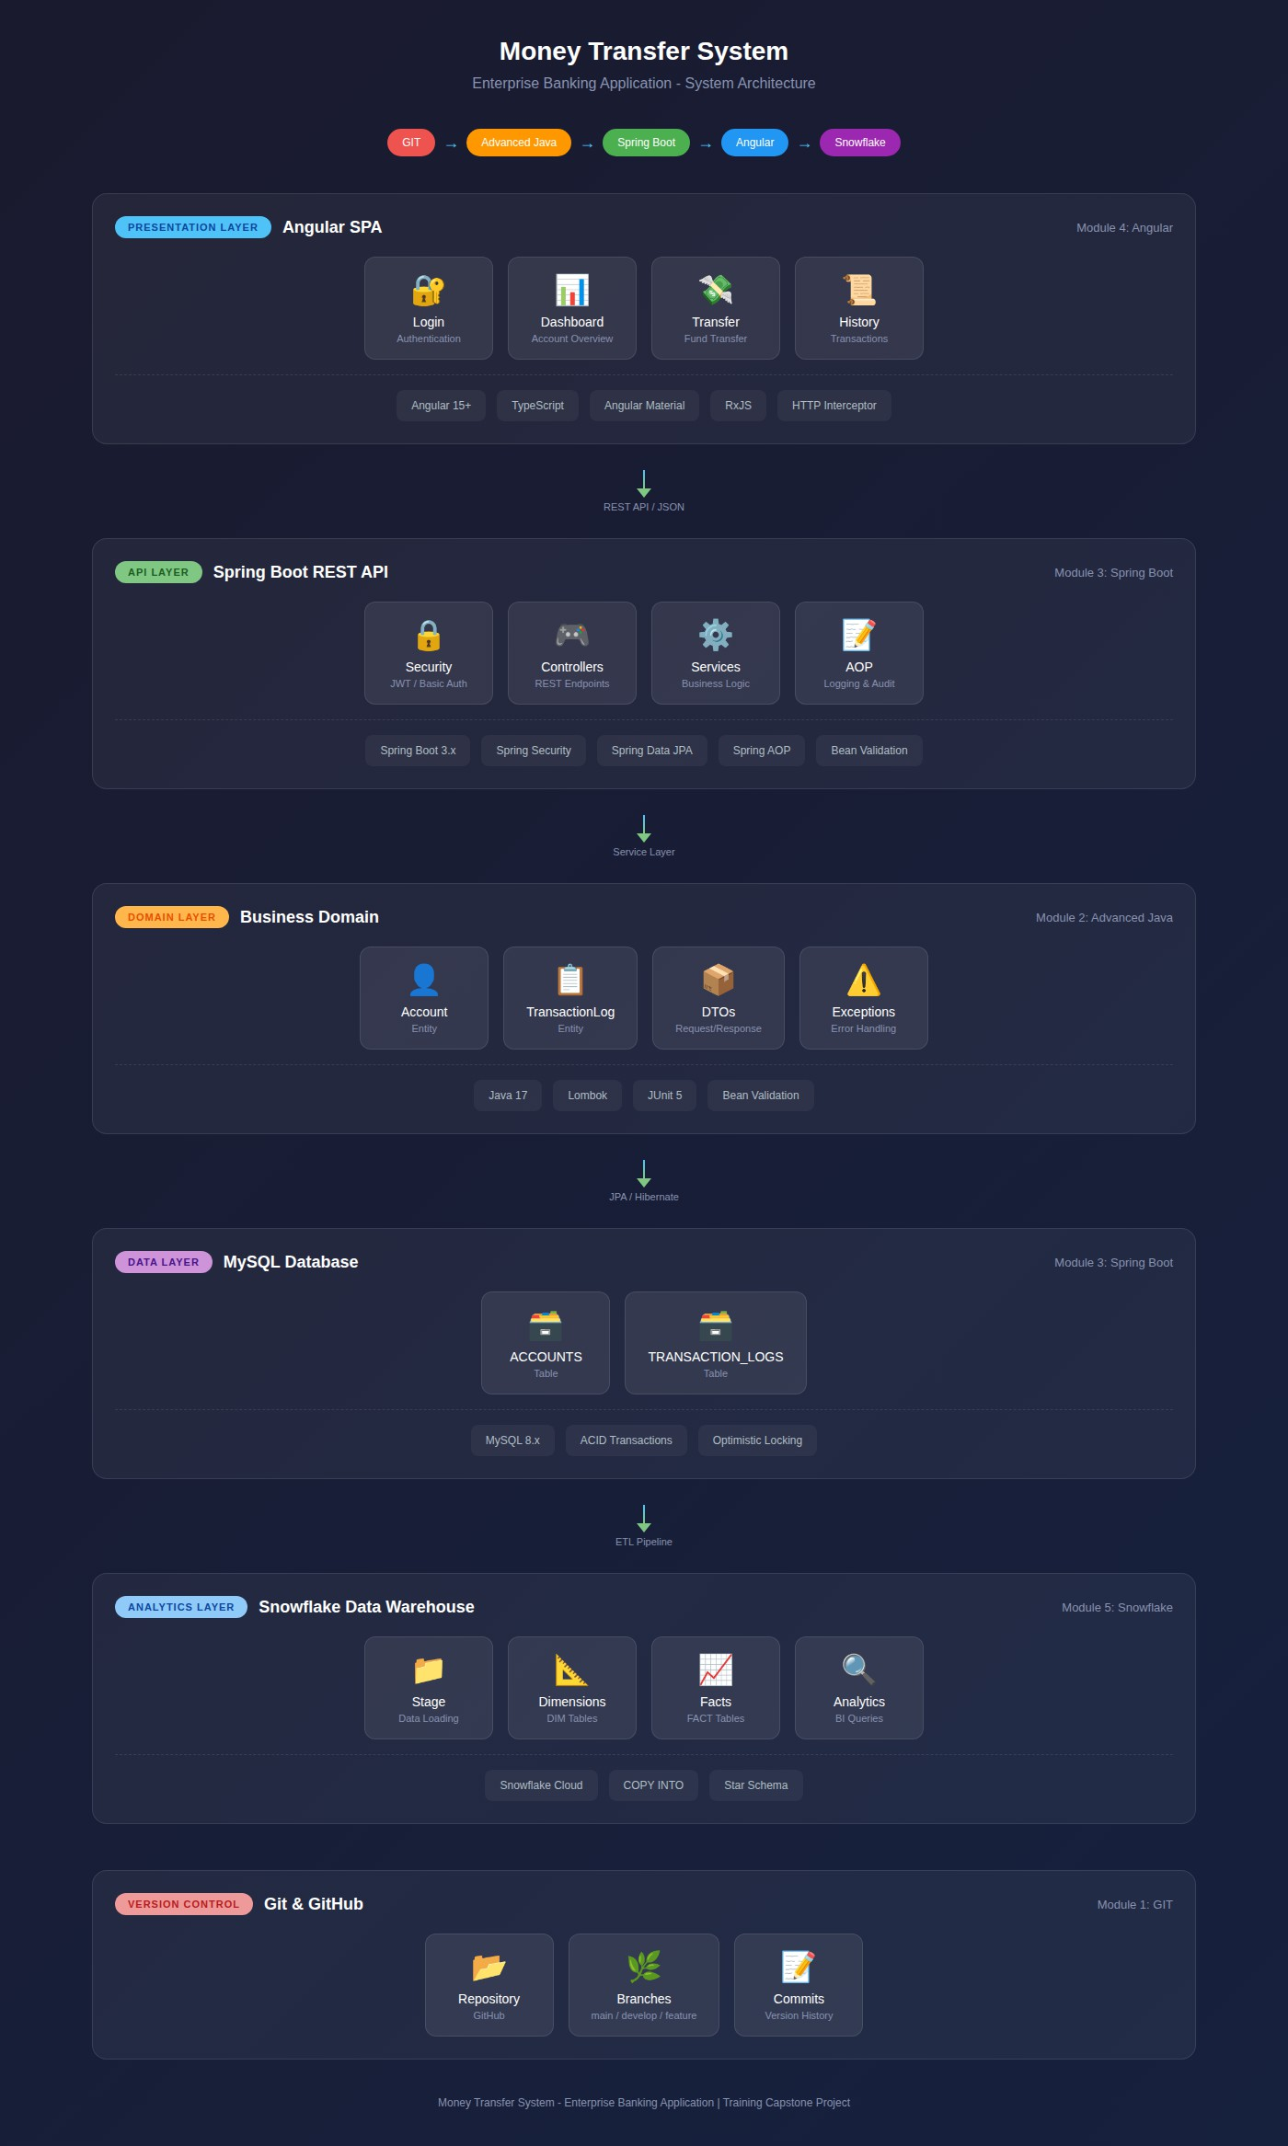

Module 1: GIT - Version Control Setup
  - Module Overview

Attribute | Details
Training Module | GIT
Project Component | Repository Setup & Version Control
Duration | 2 Hours
Prerequisites | Git installed, GitHub account

  - Tasks & Deliverables

# | Task | Description | Time
1 | Create GitHub Repository | Initialize remote repository | 0.25 hr
2 | Clone & Setup | Clone repo, configure git settings | 0.25 hr
3 | Branching Strategy | Create develop, feature branches | 0.5 hr
4 | Project Structure | Create folder hierarchy | 0.5 hr
5 | Git Configuration | .gitignore, README.md | 0.5 hr

  - Repository Structure to Create
money-transfer-system/
│
├── backend/
│ ├── src/
│ │ ├── main/
│ │ │ ├── java/

│ │ │ └── resources/
│ │ └── test/
│ └── pom.xml
│
├── frontend/
│ └── (React project - Module4)
│
├──database/
│ ├──schema.sql
│ └── seed-data.sql
│
├── docs/
│ └── (Documentation)
│
├── .gitignore
└── README.md

  - Branching Strategy

Branch | Purpose | Created From
main | Production-ready code | -
develop | Integration branch | main
feature/domain-models | Java domain classes | develop
feature/spring-boot-api | REST API development | develop
feature/React-ui | Frontend development | develop

  - Module Showcase

Showcase Item | Description
GitHub Repository | Public/Private repo with proper structure
Branch Structure | Main, develop, and feature branches
Initial Commit | Project skeleton with .gitignore and README
Commit History | Clean commit messages

Module 2: Advanced Java - Domain & Business Logic
  - Module Overview

Attribute | Details
Training Module | Advanced Java (Java 17)
Project Component | Domain Models & Business Logic
Duration | 6 Hours
Prerequisites | Module 1 complete

  - Tasks & Deliverables

# | Task | Description | Time
1 | Account Entity | Create Account class with fields & methods | 1.0 hr
2 | TransactionLog Entity | Create TransactionLog class | 0.75 hr
3 | Enums | AccountStatus,  TransactionStatus | 0.25 hr
4 | DTOs | TransferRequest,  TransferResponse, etc. | 1.0 hr
5 | Validation  Annotations | Add Bean Validation to DTOs | 0.5 hr

# | Task | Description | Time
6 | Custom Exceptions | Create exception hierarchy | 0.75 hr
7 | Business Logic | Debit/Credit methods with rules | 1.0 hr
8 | Unit Tests | JUnit tests for domain logic | 0.75 hr

  - Java 17 Features to Demonstrate

Feature | Usage in Project
Records | DTO classes (optional)
Sealed Classes | Exception hierarchy (optional)
Pattern Matching | instanceof checks
Text Blocks | Multi-line strings in tests
Enhanced Switch | Status-based logic

  - Domain Classes to Create Entities
Class | Fields | Methods
Account | id, holderName, balance, status, version, lastUpdated | debit(), credit(), isActive()
TransactionLog | id, fromAccountId, toAccountId, amount, status, failureReason, idempotencyKey, createdOn | -

Enums

Enum | Values
AccountStatus | ACTIVE, LOCKED, CLOSED
TransactionStatus | SUCCESS, FAILED

DTOs

Class | Purpose | Validations
TransferRequest | Input for transfer API | @NotNull, @DecimalMin
TransferResponse | Output for transfer API | -
AccountResponse | Output for account API | -
ErrorResponse | Error output | -

Exceptions

Exception | Use Case
AccountNotFoundException | Account ID doesn't exist
AccountNotActiveException | Account is LOCKED/CLOSED
InsufficientBalanceException | Balance < transfer amount
DuplicateTransferException | Idempotency key reused

  - Unit Tests to Write

Test Class | Test Cases
AccountTest | testDebit_Success, testDebit_InsufficientBalance, testCredit_Success
TransferRequestValidationTest | testValidRequest, testInvalidAmount, testNullFields

  - Module Showcase

Showcase Item | Description
Domain Package | Complete entity classes with JPA annotations ready
DTO Package | Request/Response objects with validation
Exception Package | Custom exception hierarchy
Unit Tests | All tests passing (green)
Git Commit | Feature branch merged to develop

Module 3: Spring Boot - REST API Development
  - Module Overview

Attribute | Details
Training Module | Spring Boot
Project Component | REST APIs, Services, Data Access
Duration | 12 Hours
Prerequisites | Module 2 complete

  - Tasks & Deliverables

# | Task | Description | Time
1 | Spring Boot Setup | Initialize project, dependencies | 1.0 hr
2 | Database Configuration | MySQL connection, application.yml | 0.5 hr
3 | JPA Repositories | AccountRepository,  TransactionLogRepository | 0.5 hr
4 | TransferService | Core transfer logic with transaction management | 2.5 hr
5 | AccountService | Account operations | 1.0 hr
6 | Idempotency Logic | Duplicate prevention mechanism | 1.0 hr
7 | TransferController | Transfer REST endpoints | 1.0 hr
8 | AccountController | Account REST endpoints | 0.75 hr
9 | Global Exception Handler | @ControllerAdvice implementation | 1.0 hr
10 | Security Configuration | Basic Auth or JWT setup | 1.5 hr
11 | AOP Logging Aspect | Method logging, execution time | 0.75 hr
12 | Database Scripts | Schema DDL, seed data | 0.5 hr

  - Spring Boot Components

Configuration Files

File | Purpose
application.yml | Database, server, logging config
pom.xml | Maven dependencies

Dependencies Required

Dependency | Purpose
spring-boot-starter-web | REST API
spring-boot-starter-data-jpa | Database access
spring-boot-starter-validation | Input validation
spring-boot-starter-security | Authentication
spring-boot-starter-aop | Aspect programming
mysql-connector-java | MySQL driver
lombok | Code generation
spring-boot-starter-test | Testing

  - REST Endpoints to Implement

Endpoint | Method | Description
/api/v1/transfers | POST | Execute fund transfer
/api/v1/accounts/{id} | GET | Get account details
/api/v1/accounts/{id}/balance | GET | Get account balance
/api/v1/accounts/{id}/transactions | GET | Get transaction history

  - Service Layer Implementation

Service | Methods
TransferService | transfer(TransferRequest), validateTransfer(), executeTransfer()
AccountService | getAccount(id), getBalance(id), getTransactions(id)

  - Cross-Cutting Concerns

Concern | Implementation
Transaction Management | @Transactional annotation
Exception Handling | @ControllerAdvice, @ExceptionHandler
Logging | AOP @Around aspect
Security | SecurityFilterChain, authentication

  - Module Showcase

Showcase Item | Description
Running Application | Spring Boot app starts successfully
Postman Collection | All APIs tested and working
Database | Tables created, seed data loaded
Security | Protected endpoints, auth required
Logs | AOP logging visible in console
Git Commit | Feature branch merged to develop

Module 4: React - Frontend Application

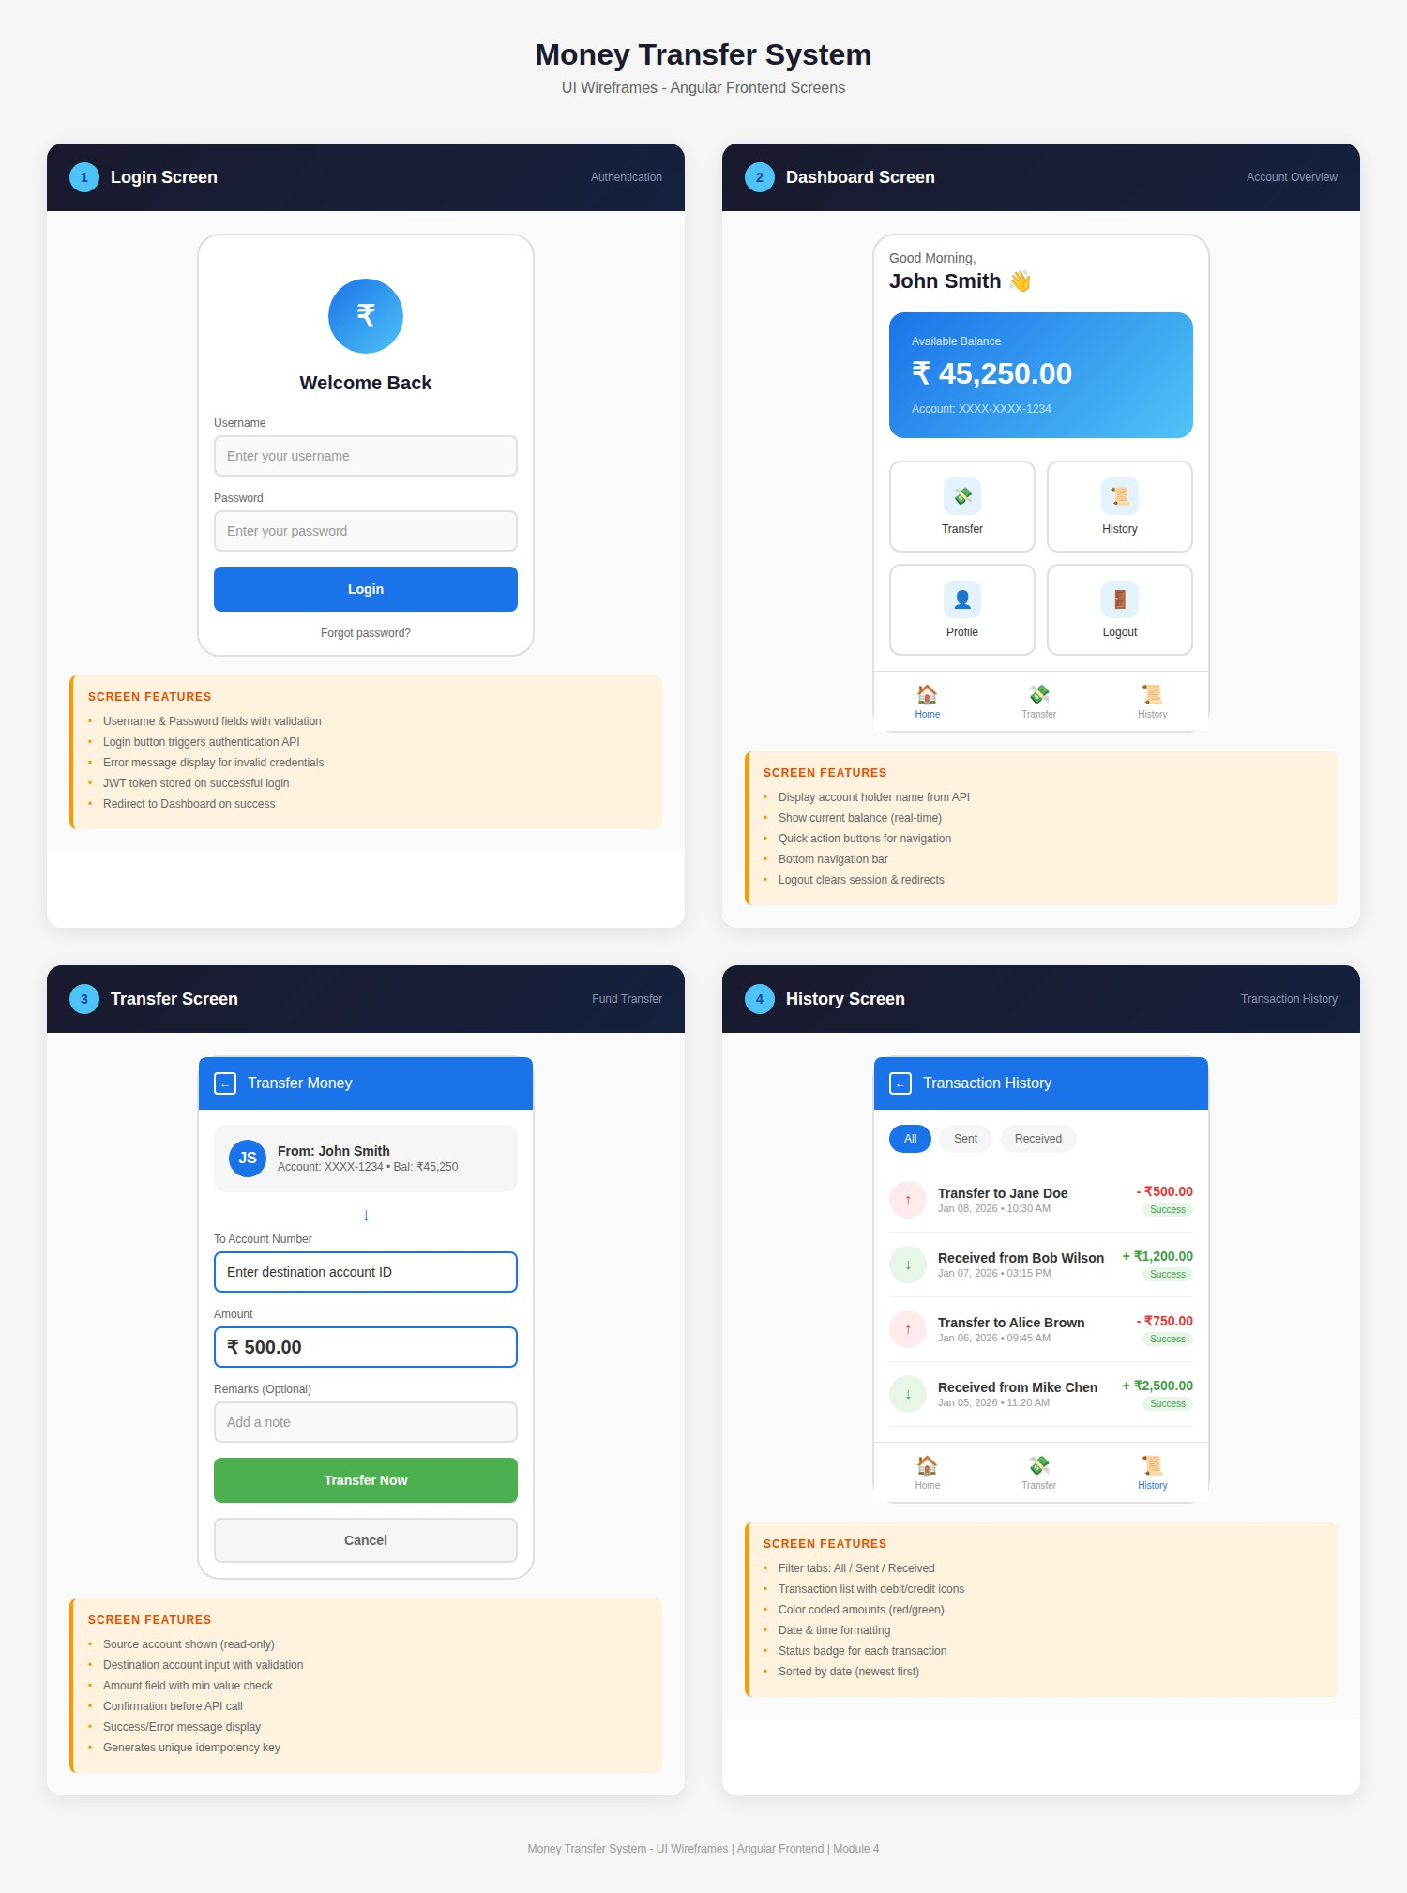

  - Module Overview

Attribute | Details
Training Module | React
Project Component | Single Page Application (UI)
Duration | 8 Hours
Prerequisites | Module 3 complete

  - Tasks & Deliverables

# | Task | Description | Time
1 | React Setup | New project, routing, material | 0.5 hr
2 | Auth Service | Login logic, token storage | 1.0 hr
3 | Login Page | Login form, validation, error handling | 1.0 hr
4 | HTTP  Interceptor | Auth header injection | 0.5 hr
5 | Dashboard Page | Balance display, navigation | 2.0 hr
6 | Transfer Page | Transfer form, validation, API call | 2.0 hr
7 | History Page | Transaction table, formatting | 1.0 hr

  - React Components

Component | Features
LoginComponent | Form, validation, error messages, redirect
DashboardComponent | Welcome message, balance card, action buttons
TransferComponent | Form, validation, confirmation modal, result display
HistoryComponent | Table, date formatting, status badges

  - React Services

Service | Methods
AuthService | login(), logout(), isAuthenticated(), getToken()
AccountService | getAccount(), getBalance(), getTransactions()
TransferService | transfer()

  - Screen Specifications Login Screen
Element | Type | Details
Username | Input | Required, text
Password | Input | Required, password type
Login Button | Button | Submits form
Error Alert | Alert | Shows on failure

Dashboard Screen

Element | Type | Details
Welcome Banner | Text | "Welcome, {holderName}"
Balance Card | Card | Current balance, large font
Transfer Button | Button | Navigate to transfer
History Button | Button | Navigate to history
Logout Button | Button | Clear session

Transfer Screen

Element | Type | Details
From Account | Display | Current account (readonly)
To Account | Input | Destination account ID
Amount | Input | Transfer amount
Transfer Button | Button | Submit transfer
Cancel Button | Button | Return to dashboard

Element | Type | Details
Result Message | Alert | Success/Error message

History Screen

Element | Type | Details
Transaction Table | Table | List of transactions
Date Column | Column | Formatted date/time
Type Column | Column | DEBIT (red) / CREDIT (green)
Amount Column | Column | Formatted currency
Status Column | Column | Badge (Success/Failed)

  - Module Showcase

Showcase Item | Description
Running React App | ng serve working
Login Flow | Authentication working
Dashboard | Balance displayed from API
Transfer Flow | End-to-end transfer working
History View | Transactions displayed
Full Stack Demo | Frontend + Backend integrated
Git Commit | Feature branch merged to develop

Module 5: Snowflake - Data Analytics
  - Module Overview

Attribute | Details
Training Module | Snowflake

Attribute | Details
Project Component | Data Warehouse & Analytics
Duration | 2 Hours
Prerequisites | Module 3 complete (transaction data)

  - Tasks & Deliverables

# | Task | Description | Time
1 | Snowflake Setup | Database, warehouse, schema | 0.25 hr
2 | Stage Configuration | Internal/External stage | 0.25 hr
3 | Dimension Tables | DIM_ACCOUNT, DIM_DATE | 0.5 hr
4 | Fact Tables | FACT_TRANSACTIONS | 0.5 hr
5 | ETL Pipeline | COPY INTO commands | 0.25 hr
6 | Analytics Queries | Business intelligence queries | 0.25 hr

  - Snowflake Objects to Create Database Structure
Object | Name | Purpose
Database | MONEY_TRANSFER_DW | Data warehouse
Schema | ANALYTICS | Analytics objects
Warehouse | COMPUTE_WH | Query processing

Dimension Tables

Table | Columns
DIM_ACCOUNT | account_key, account_id, holder_name, status, effective_date
DIM_DATE | date_key, full_date, day, month, year, quarter

Fact Tables

Table | Columns
FACT_TRANSACTIONS | transaction_key, account_from_key, account_to_key, date_key, amount, status

  - Analytics Queries

Query | Purpose
Daily Transaction Volume | Count and sum by date
Account Activity | Most active accounts
Success Rate | Percentage of successful transfers
Peak Hours | Busiest transaction times
Average Transfer Amount | Mean transfer value

  - Module Showcase

Showcase Item | Description
Snowflake Objects | Database, schema, warehouse created
Dimensional Model | Fact and dimension tables
Data Loaded | Transaction data in warehouse
Analytics Queries | Working queries with results
Git Commit | Scripts committed to repository

Functional Requirements
  - Core Features

ID | Feature | Module | Description
FR-01 | Fund Transfer | Spring Boot | Transfer funds between accounts

ID | Feature | Module | Description
FR-02 | Account Validation | Spring Boot | Verify account existence/status
FR-03 | Balance Check | Spring Boot | Ensure sufficient funds
FR-04 | Transaction Logging | Spring Boot | Record all transfers
FR-05 | Idempotency | Spring Boot | Prevent duplicates
FR-06 | Balance Inquiry | Spring Boot + React | View current balance
FR-07 | Transaction History | Spring Boot + React | View past transactions
FR-08 | User Authentication | Spring Boot + React | Secure login

Non-Functional Requirements

ID | Requirement | Module | Implementation
NFR-01 | ACID Compliance | Spring Boot | @Transactional
NFR-02 | Concurrency Control | Spring Boot | Optimistic locking
NFR-03 | Security | Spring Boot | Auth + Validation
NFR-04 | Audit Trail | Spring Boot | AOP logging
NFR-05 | Version Control | GIT | Git branching

Domain Model
  - Account Entity

Field | Type | Description
id | Long | Primary key
holderName | String | Account holder name
balance | BigDecimal | Current balance
status | AccountStatus | ACTIVE/LOCKED/CLOSED
version | Integer | Optimistic lock
lastUpdated | Timestamp | Last modified

  - TransactionLog Entity

Field | Type | Description
id | UUID | Primary key
fromAccountId | Long | Source account
toAccountId | Long | Destination account
amount | BigDecimal | Transfer amount
status | TransactionStatus | SUCCESS/FAILED
failureReason | String | Error if failed
idempotencyKey | String | Unique request ID
createdOn | Timestamp | Transaction time

Database Design
  - OLTP Tables (MySQL)
ACCOUNTS Table

Column | Type | Constraints
id | BIGINT | PRIMARY KEY, AUTO_INCREMENT
holder_name | VARCHAR(255) | NOT NULL
balance | DECIMAL(18,2) | NOT NULL

Column | Type | Constraints
status | VARCHAR(20) | NOT NULL
version | INT | DEFAULT 0
last_updated | TIMESTAMP | AUTO UPDATE

TRANSACTION_LOGS Table

Column | Type | Constraints
id | VARCHAR(36) | PRIMARY KEY
from_account | BIGINT | FOREIGN KEY
to_account | BIGINT | FOREIGN KEY
amount | DECIMAL(18,2) | NOT NULL
status | VARCHAR(20) | NOT NULL
failure_reason | VARCHAR(255) | NULLABLE
idempotency_key | VARCHAR(100) | UNIQUE
created_on | TIMESTAMP | DEFAULT NOW

  - Analytics Tables (Snowflake) FACT_TRANSACTIONS
Column | Type | Description
transaction_key | NUMBER | Surrogate key
account_from_key | NUMBER | FK to DIM_ACCOUNT
account_to_key | NUMBER | FK to DIM_ACCOUNT
date_key | NUMBER | FK to DIM_DATE
amount | DECIMAL(18,2) | Transfer amount
status | VARCHAR(20) | Transaction status

API Specification
  - Transfer API
Endpoint: Request:
{
"fromAccountId":1, "toAccountId":2, "amount":500.00,
"idempotencyKey":"uuid-string"
}
POST /api/v1/transfers

Success Response (200):
{
"transactionId":"TRX-uuid", "status":"SUCCESS",
"message":"Transfer completed", "debitedFrom":1,
"creditedTo":2, "amount":500.00
}

Error Response (4xx):
{
"errorCode":"TRX-400", "message":"Insufficient balance"
}

  - Account APIs

Endpoint | Method | Response
/api/v1/accounts/{id} | GET | Account details
/api/v1/accounts/{id}/balance | GET | Balance only
/api/v1/accounts/{id}/transactions | GET | Transaction list

Business Rules

# | Rule | Error Code
1 | Accounts must be different | VAL-422
2 | Source account must exist | ACC-404
3 | Destination account must exist | ACC-404
4 | Source account must be ACTIVE | ACC-403
5 | Destination account must be ACTIVE | ACC-403
6 | Amount must be  0 | VAL-422
7 | Source balance >= amount | TRX-400
8 | Idempotency key must be unique | TRX-409
9 | Debit before credit | -
10 | Log every transfer | -

Error Handling
  - Error Catalog

Code | Message | HTTP
ACC-404 | Account not found | 404

Code | Message | HTTP
ACC-403 | Account not active | 403
TRX-400 | Insufficient funds | 400
TRX-409 | Duplicate transfer | 409
VAL-422 | Invalid input | 422

Security Implementation

Feature | Implementation
Authentication | Basic Auth or JWT
Protected Routes | All /api/** endpoints
Input Validation | Bean Validation
Password Storage | BCrypt encoding

Deliverables by Module
  - Module-wise Deliverables

Module | Deliverables | Showcase
GIT | GitHub repo, branches, project structure | Repository walkthrough
Advanced Java | Domain classes, DTOs, exceptions, unit tests | Tests passing
Spring Boot | REST APIs, services, security, DB scripts | Postman demo
React | SPA with 4 screens, API integration | Full-stack demo
Snowflake | DW schema, ETL, analytics queries | Query results

  - Final Deliverables

# | Deliverable | Description
1 | GitHub Repository | Complete source code
2 | Backend Application | Working Spring Boot app
3 | Frontend Application | Working React app
4 | Database Scripts | DDL + seed data
5 | Snowflake Scripts | DW setup + queries
6 | Unit Tests | Passing test suite
7 | Documentation | README with setup guide

Evaluation Criteria

